**Project Design Phase-I**

**Solution Architecture**

|  |  |
| --- | --- |
| Date | 09 November 2022 |
| Team ID | PNT2022TMID26125 |
| Project Name | Inventory Management System for Retailers |
| Maximum Marks | 4 Marks |

**Solution Architecture:**

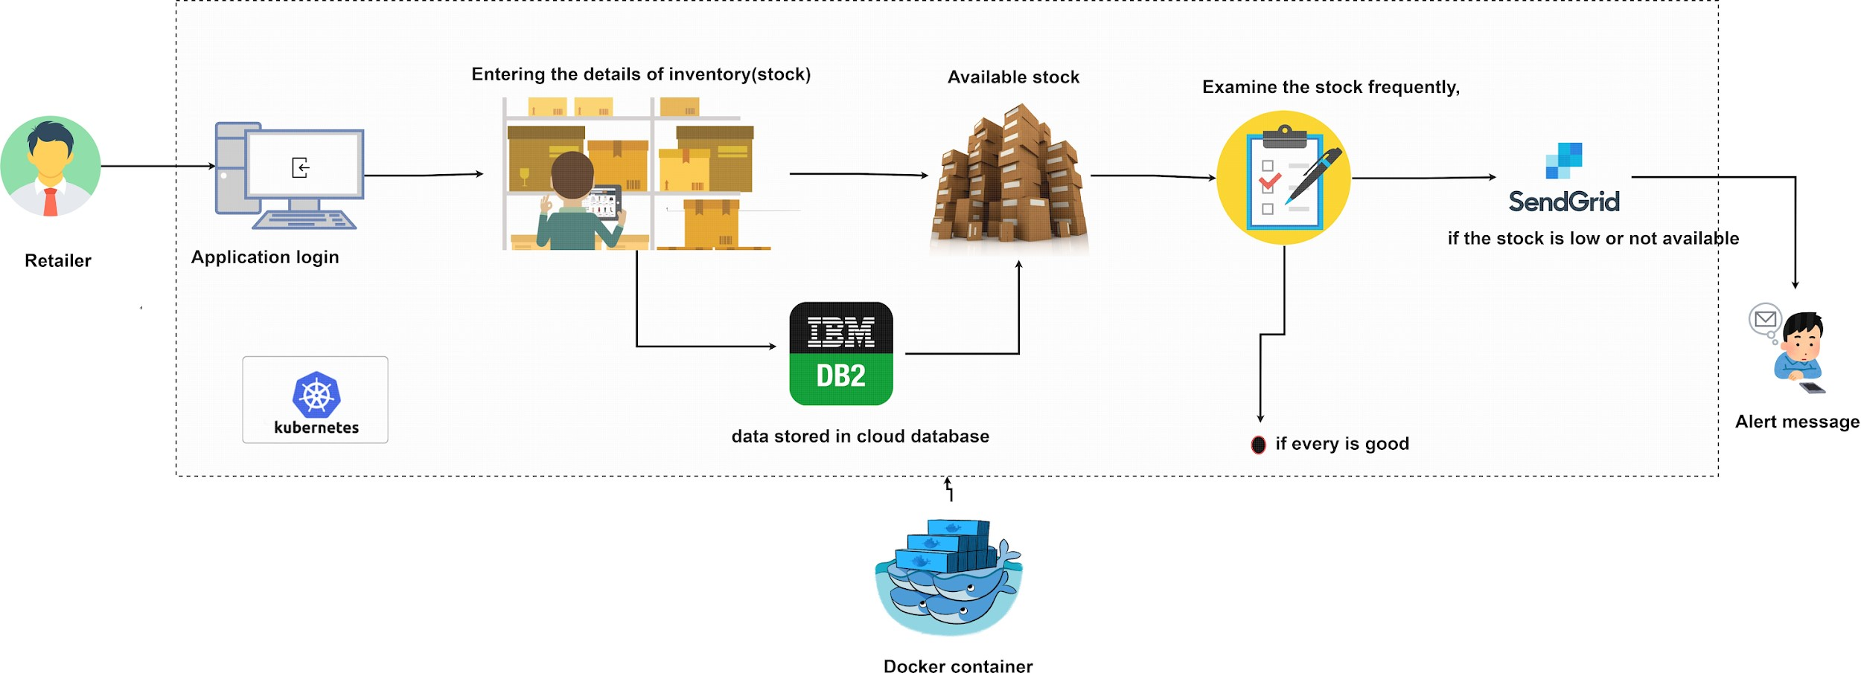

**Solution Architecture for Inventory Management**

**System For Retailers**